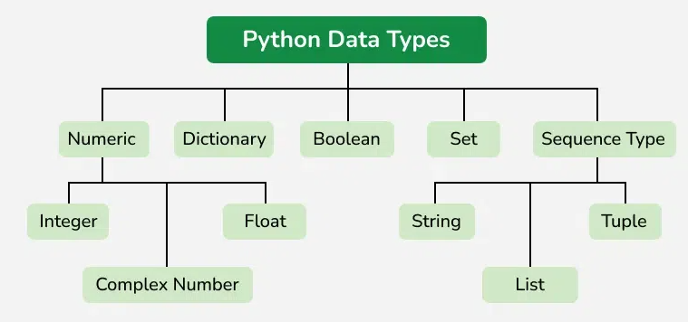
Python’s built-in data types fall into categories: Numeric, Sequence, Mapping, Set, Boolean, and Binary. Choose types based on mutability, ordering, and hashability for performance and correctness.
Numeric Types
int — arbitrary-precision integers; use for counts and indices.
float — double-precision floating point; use for measurements and approximations.
complex — real + imaginary; use in signal processing and complex arithmetic.
Sequence Types
str (immutable text), list (ordered, mutable), tuple (ordered, immutable), range (memory-efficient integer sequence). Use sequences when order matters; prefer immutable types for safety and hashability.
Mapping Type d={“key”:”value”}
dict — key→value mapping with fast lookup; keys must be hashable. Use for labeled records and O(1) lookups.
Dict ={2:”Two”, 3:”Three”}
Set Types (1,2,3,2,3,4)
set (mutable, unique items) and frozenset (immutable). Use for deduplication and fast membership tests.
Boolean and Binary Types
bool (True/False),

Immutable
S=”Hello World”
Memory side: s=123 Hello World
S=”Helloworld” s=124-> Helloworld

Mutable:
S=”Hello World”
Memory side: s=123 Hello World
S=”Helloworld” s=123-> Helloworld

Comparison Table
Type Category | Examples | Mutability | Use Cases
Numeric | int; float; complex | Immutable | Counts; calculations
Sequence | str; list; tuple; range | str/tuple immutable; list mutable | Text; ordered collections
Mapping | dict | Mutable | Labeled lookups; configs
Set | set; frozenset | set mutable; frozenset immutable | Deduplication; membership
Boolean/Binary | bool; bytes; bytearray | bool immutable; bytes immutable; bytearray mutable | Flags; I/O buffers
Code Examples
# Numeric
print(42)
print(3.14159)
print(1+2j)

# Sequence
name = "Alice"
numbers = [1, 2, 3]
coords = (10.0, 20.0)
for i in range(5):
print(i)

# Mapping
person = {"name": "Alice", "age": 25}
print(person["age"])

# Set
unique = set([1,2,3,2,3])
print(unique)

# Boolean and Binary
flag = True
data = b"hello"
arr = bytearray(b"\x00\x01")
Key Takeaways and Performance Tips
- Mutability matters: use mutable containers (lists, dicts, sets) when you need to change contents; use immutable types (tuple, frozenset, str) for safety and hashability.
- Ordering matters: use sequences when order is important.
- Uniqueness matters: use sets for deduplication and fast membership checks.
- Labeling matters: use dicts for labeled data and O(1) lookups.
- Performance: prefer range for large integer sequences; avoid repeated string concatenation—use str.join or io.StringIO.

